Max Marks: 4 Marks
Project Name: Book A Doctor
Student Name: Navendhiran C
Date: 04 Aug 2026
PROJECT DESIGN PHASE-II

Data Flow Diagram & User Stories

Data Flow Diagrams (DFD)
A Data Flow Diagram (DFD) is a widely used visual model that maps how information moves through a system. A well-structured DFD makes the requirements easy to follow by showing where data originates, which processes transform it, and where it is ultimately held within the Book A Doctor platform.
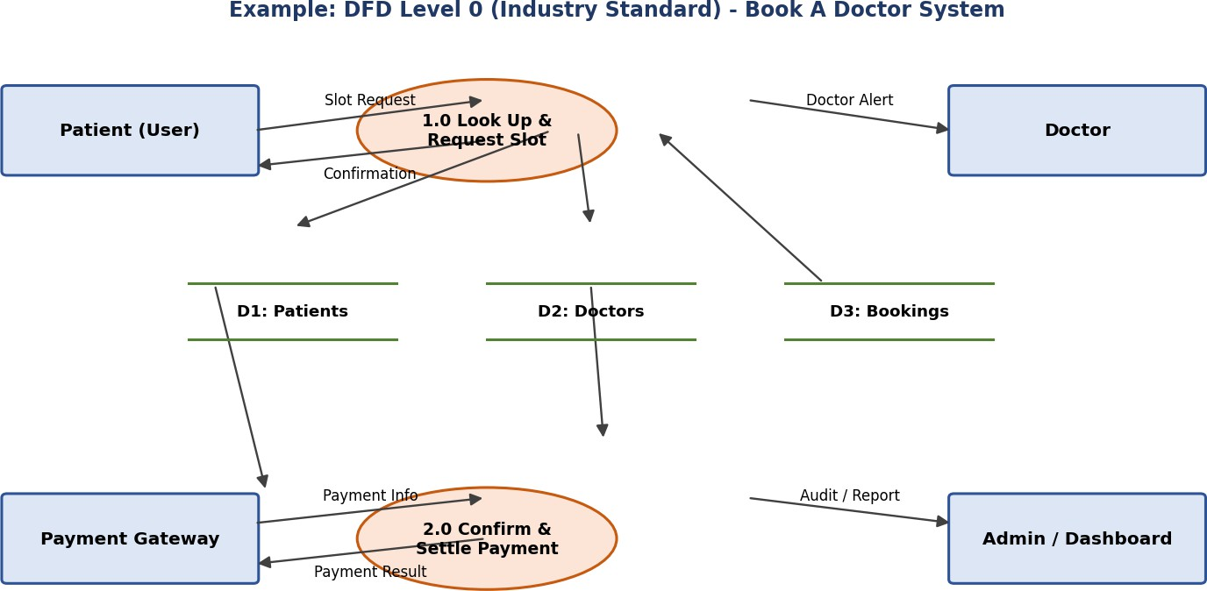

System Workflow Narrative
Search & Selection: The patient enters a location and specialty, which queries the D2: Doctors store for currently active schedules.
Slot Request: Details of the chosen slot are checked against the D1: Patients record and held temporarily pending confirmation.
Payment Processing: Billing details are forwarded to the Payment Gateway to complete the transaction.
Confirmation & Storage: Once payment succeeds, the booking is written to D3: Bookings, and confirmation slips are issued to the Patient, Doctor, and System Admin.

User Stories Template
Use the table below to record every system capability, user requirement, and development priority planned for the Book A Doctor system.

User Type | Functional Require | mIDent | User Story / Task | Acceptance Criteria | Priority | Release
Customer (Mobile User) | Registration | USN-1 | As a user, I can register for the application by entering my email, password, and confirming my password. | I can access my account  / dashboard | High | Sprint-1
Customer (Mobile User) | Registration | USN-2 | As a user, I get a confirmation email right after registering for the application. | Confirmation email is received and the confirm link works | High | Sprint-1
Customer (Mobile User) | Registration | USN-3 | As a user, I can sign up for the application using my Facebook account. | I can register and reach the dashboard via Facebook | Low | Sprint-2
Customer (Mobile User) | Registration | USN-4 | As a user, I can sign up for the application using my Gmail account. | I can register and reach the dashboard via Gmail | Medium | Sprint-1
Customer (Mobile User) | Login | USN-5 | As a user, I can log into the application by entering email & password. | I can log into user dashboard successfully | High | Sprint-1
Customer (Web User) | Doctor Search | USN-6 | As a patient, I can look up doctors filtered by specialty, location, and open time slots. | Verified doctor profiles and open slots are displayed | High | Sprint-1
Customer (Web User) | Booking & Payment | USN-7 | As a patient, I can choose an open slot and pay online to finalize an appointment. | Instant SMS and email booking confirmation generated | High | Sprint-2
Doctor | Schedule Management | USN-8 | As a doctor, I can manage my consultation availability and adjust working hours. | Updated schedule reflects immediately on search view | High | Sprint-1
Customer Care Executive | Support & Cancellation | USN-9 | As support staff, I can help patients cancel appointments and initiate refunds. | Cancellation logs generated and refund processed | Medium | Sprint-2
Administrator | Doctor Verification | USN-1 0 | As an admin, I can check and confirm medical licenses before a doctor profile goes live. | Only verified doctors appear on search results | High | Sprint-1

